Lab 1
Cable Making
Objective:
The purpose of this lab is for the student to create a one-meter CAT5E straight thru network cable. Students will utilize various tools to create a proper network cable. Students will also utilize a network cable tester to verify that their cable is functioning properly.

Diagram:

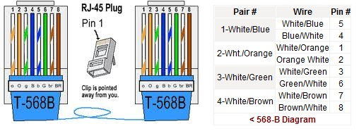

Components:
1 – Spool of Cat 5E Wire
2 – RJ-45 Plugs

Questions:
- What tools did you utilize to complete this lab?

  - _____Cable stripper_______________
  - _____Crimper_______________________
  - _____RJ45 plugs______________________
  - ______CAT 5E cable___________________
  - ______Cable tester_______________

- What are the steps you used to complete the cable?

  - ____Cut the cable length___________
  - ____Strip off the plastic____________
  - ____Untwist the wires______________
  - ____Arrange the wires in the proper order__
  - ____Straighten out the wires to get kinks out__
  - ____Put the wires into the RJ45 plug___
  - ____Use the crimper to crimp the ends_______
  - ____Test the cable___

- Draw both ends of a CAT5B crossover cable. Label the color codes and pin numbers on both ends. You can use MS Paint or just find an image in Google images.

1 2 3 4 5 6 7 8
1 2 3 4 5 6 7 8

g G o B b O br BR
o O g B b G br BR
T-568B
T-568A

- Get pricing for 100 feet of CAT5E Network cable and 20 RJ-45 plugs. I like to use www.cdw.com. Their site is easy to navigate.

  - Price of wire ____$191.99 for 1000ft, so $19.20 for 100 ft ____
  - Price of RJ – 45 plugs _____$21.99 for 50, so $0.44 each_____
  - Cost per cable if 10 (10ft) cables are made __$2.80 ($1.92 + .88)_
  - Cost of 1 (10ft) premade cable _______$6.99_______________
  - Which is the better value? ____Making your own is technically less expensive, but labor intensive, and the bulk products available are more than you need to purchase, so you end up spending more. I would personally say that the premade cable is worth the extra cost.___

- What did you learn by completing this lab?

__I learned how to make a functional Cat5e straight through cable, the difference between it and a crossover cable, and how to use the tools necessary to create the cable._____________

